**Outline Use Case**

***World Arts Film Festival Voting System***

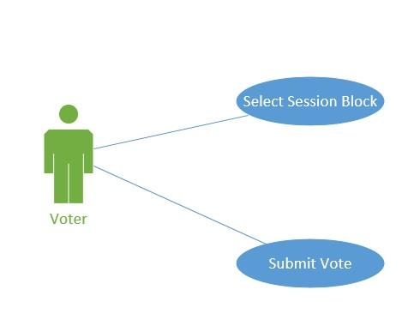

*Select Session Block*

**Brief Description**

Voter can select the desired session from the session blocks page.

**Basic Flow**

1. Look for the session that voter attended or any session he wants.
2. Select the sessions where films are.

Seems to be incomplete flow? What happens after selecting session? Selecting something is not a use case

**Alternative Flows**

1. Voter can’t find the session block he wants.
2. Voter wants to vote for a film which was presented last session yesterday.

**Pre-conditions**

Admin loads all the session blocks with the respective films.

**Post-condition**

Everything is on place that the voter can vote.

**Scenarios**

* Voter choose the desired session block- **basic flow**
* Voter can’t find a session because that session was part of yesterday schedule-**basic flow, alternative flow #1 and #2.**

*Submit Vote*

**Brief Description**

Voter choose the desired film on one session or few session and submit his vote or votes for the films.

**Basic Flow**

1. Voter chooses the desired film in the selected section.
2. Voter click on the radio button below the desired film.
3. Voter submit his vote clicking the submit button.
4. Once Voter has voted the session grey out.
5. Voter can repeat step 1 to 4 as many session he wants.

**Alternative Flows**

1. Voter wants to vote for two films in the same session.
2. Voter submits vote and session does not grey out.

**Pre-conditions**

Voter has choose the session or sessions where the films are.

**Post-condition**

System store vote on the database and displays it on the leaderboard, and now admin can makes his reports.

**Scenarios**

* Voter submit vote for the desired film.-**basic flow**
* Voter think both of the films deserve his vote, but films are in the same session block.-**basic flow, alternative flow #1.**